**Increasing the distribution of Pfizer Covid-19 vaccine in Africa**



Group 3

A2: Group Assignment: Report

## Data Visualization & Analysis - QTM-6032 - DMIB1

Prof. Thomas Kurnicki

March 1, 2023

**One shot at a time - Pfizer's efforts to increase vaccine access in Africa**

Covid-19 took the world by storm. Many lives were lost, jobs were lost, businesses shut down completely in different regions of the world. However, the most affected region was the AFRO Region which had the lowest vaccination distribution rate amongst other regions. Our story focuses on the vaccine distribution challenges faced by the AFRO Region which includes poor government strategies, infrastructural challenges, reluctance amongst the citizens to take vaccinations, shortage of supplies, etc.

Most countries in Africa had less than 10% vaccine coverage rate. Few outliers were - Seychelles, Mauritius who were very successful in their vaccination campaign [Appendix 7.0]. Also, the AFRO region was lagging the most in terms of vaccine distribution rate [Appendix 8.0]. Many countries in this region have less than 10% of its total population vaccinated - which includes countries like Ghana, Nigeria, Togo, Kenya, etc.

**Potential reasons for this were:** Corruption and fraud in Africa have had a significant impact on vaccine distribution during the COVID-19 pandemic. There have been instances of corrupt government officials or healthcare providers prioritizing themselves and their families for vaccination, selling vaccines to the highest bidder, and issuing fake health cards or vaccination certificates in exchange for bribes. These activities not only deny access to the vaccine but also undermine public trust in the healthcare system. Fake vaccine cards and COVID-19 papers are also prevalent in Africa, linked to the limited availability of vaccines, high demand, and lack of coordination in vaccination records. Wealthy states collaborating with corporate giants have also been accused of betraying Africa with empty slogans and false promises, while the pandemic has worsened due to poor healthcare infrastructure, inequality, and increasing gender-based violence.

Another interesting fact was that Pfizer wasn’t the most popular vaccine used in the AFRO region with Covidshield being used by the most no. of countries (39) [Appendix 5.0].

We have come up with a few strategies for Pfizer to increase their presence in Africa. Pfizer should collaborate with international organizations like WHO and UNICEF to secure funding for vaccine distribution in remote areas and reduce the equity gap between low and high-income countries in Africa. They should also offer technological support to increase the usage of advanced technologies like self-driving drones. To address logistical challenges, Pfizer should work closely with partners and new couriers to build viable supply chains that cover remote areas, and establish new warehouses in Ghana, Kenya, and South Africa. Lastly, to reduce vaccine hesitancy, we created an awareness campaign featuring influential African football players in partnership with the Confederation of African Football.

To conclude, the AFRO Region is suffering the lowest vaccination distribution rate, having lots of country with less than 10% of their population vaccinated. Corruption, fraud, and vaccine hesitancy are only some reasons for this. In order to increase Pfizer´s presence in Africa, they should collaborate with international organizations such as WHO and UNICEF, offer more than just the vaccine, contribute with technological support, build viable supply chains, and launch an awareness campaign featuring influential African football players. To solve this excessive problem, we plan to leverage data visualization through Tableau, supported by primary and secondary research.

**APPENDIX**

**1. Top 5 countries in the world in terms of Total Vaccination.**

China, India, USA, Brazil, Japan

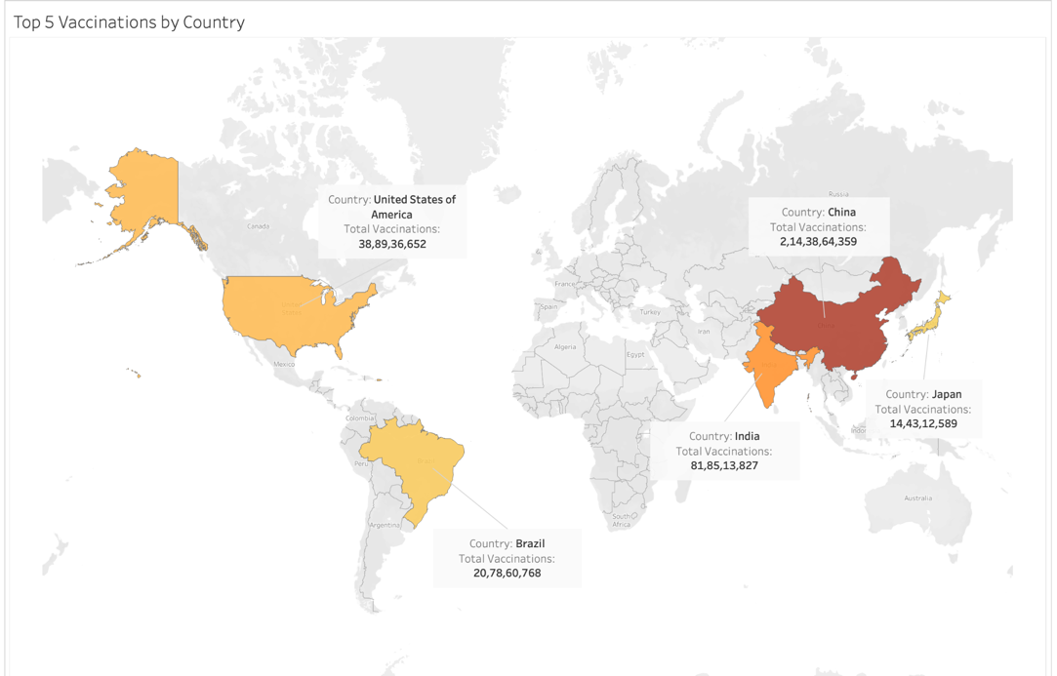

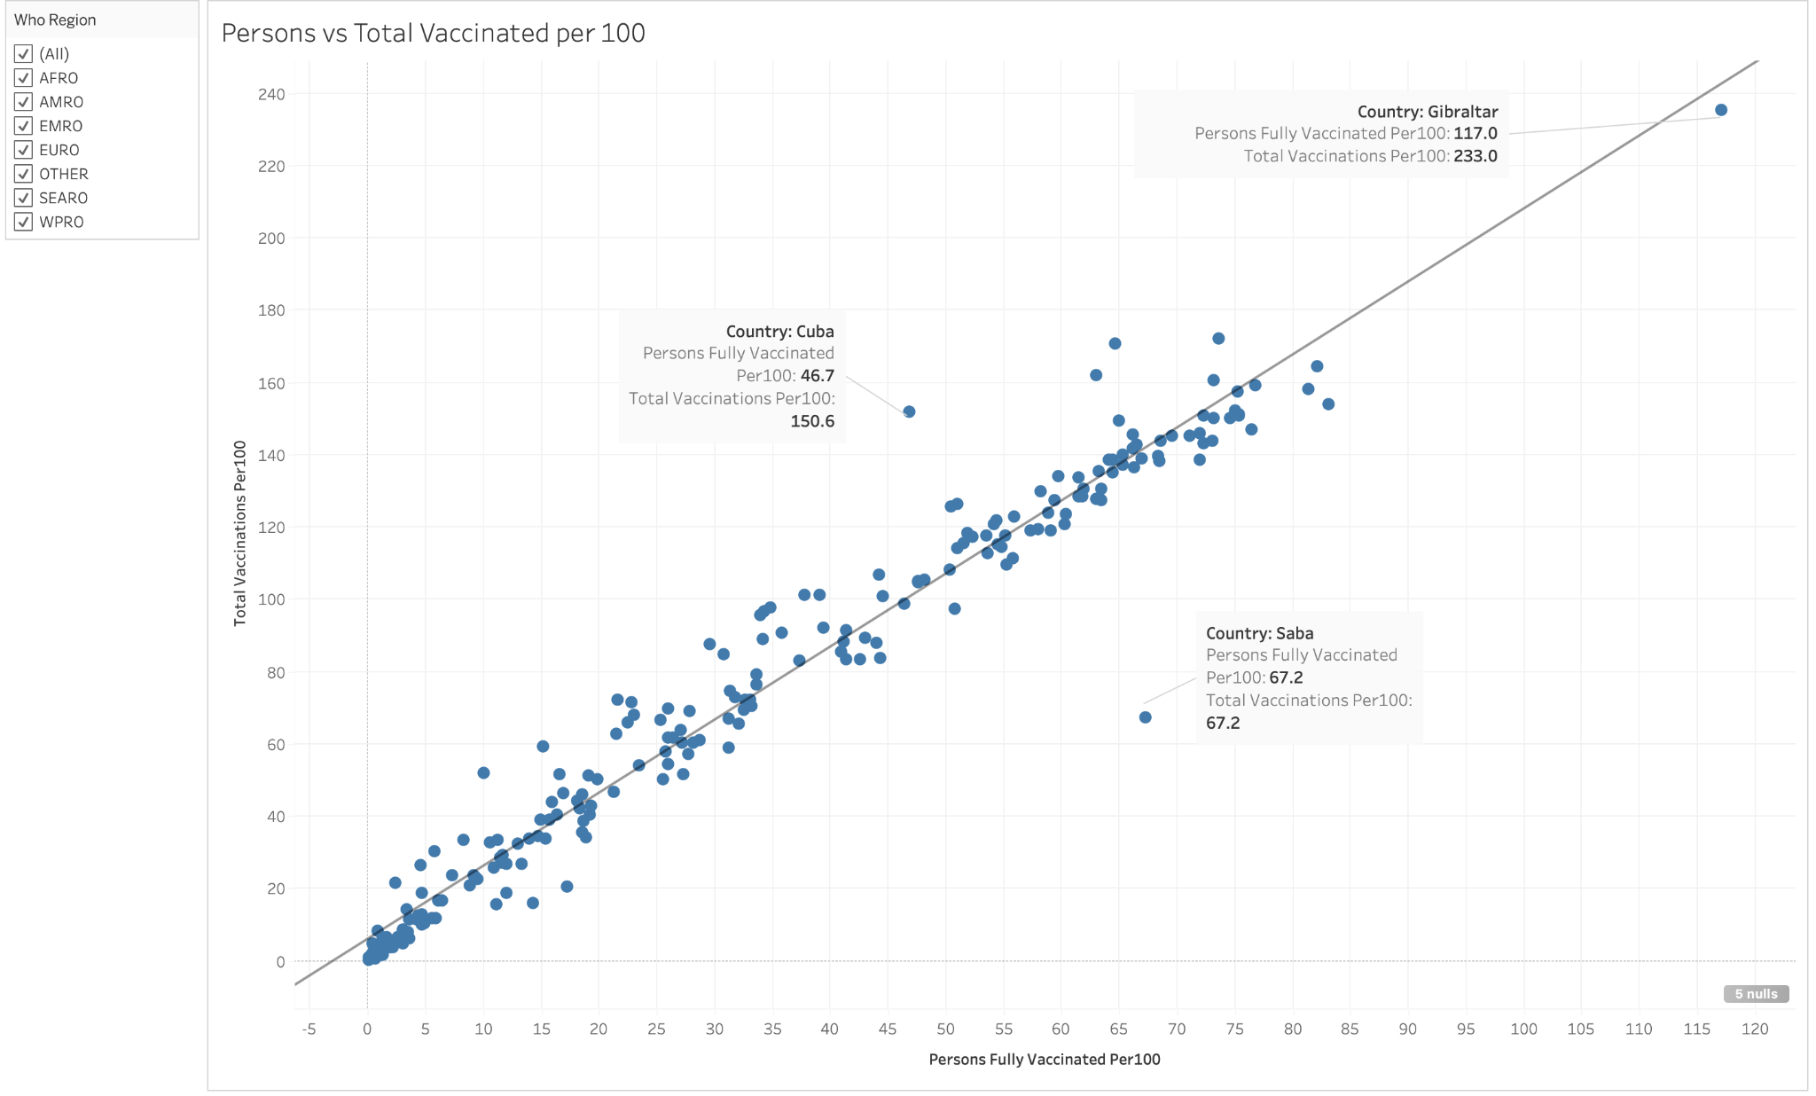**2. Person fully vaccinated per 100 vs Total vaccinations per 100 (Scatter plot)**

**Outliers:**

1. **Gibraltar:** Home to roughly 30,000 people, Gibraltar had two key advantages in the vaccine race: its minuscule size, covering less than three square miles of rock, and a steady stream of vaccine doses imported from Britain. That’s allowed the government to begin giving shots to [thousands of workers](https://www.politico.eu/article/vaccine-victory-within-gibraltars-reach/) who live in Spain but commute across the border to Gibraltar every day.
2. **Saba:** Saba has the same number of persons fully vaccinated per 100 (67.3) and total vaccinations per 100 (67.3). Every vaccinated habitant in Saba is fully vaccinated. Saba, which is a special municipality of the Netherlands, has announced that it will consider all individuals who have received the first dose of a two-dose COVID-19 vaccine series as fully vaccinated. This policy was implemented in response to challenges in obtaining the second dose of the vaccine due to logistical constraints and supply issues.
3. **Cuba:** Cuba had a remarkable total vaccinations per 100 rate equal to 150.6. Cuba's achievement of producing its own vaccines and vaccinating 90% of its population is remarkable. Cuba's biotech sector has developed five different Covid vaccines, including Abdala, Soberana 02, and Soberana Plus, all of which have demonstrated upwards of 90% efficacy against symptomatic Covid with three doses. These vaccines are particularly significant for low-income countries because they are affordable to produce, can be manufactured at a large scale, and do not require deep freezing. [2]

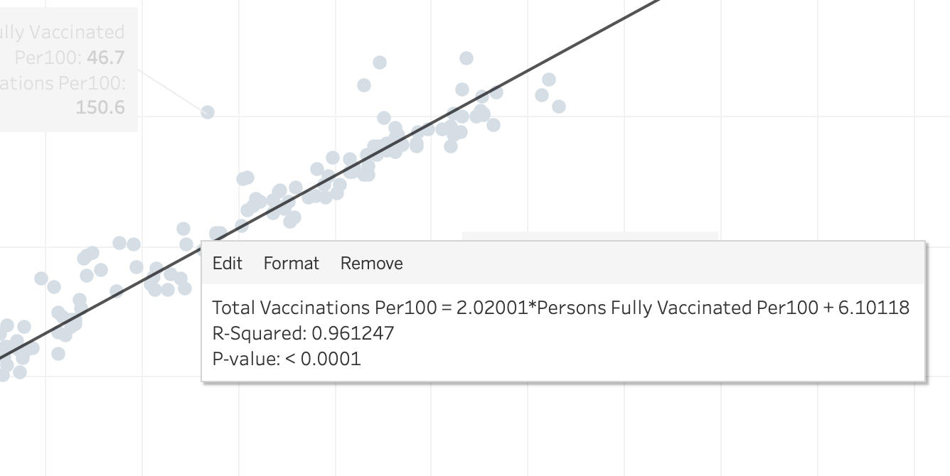

Generally, a p-value of less than 0.05 is considered statistically significant, which means that there is less than a 5% chance that the observed effect is due to chance. Therefore, a p-value of less than 0.0001 for the scatter plot between Person fully vaccinated per 100 and Total vaccinations per 100 is considered extremely significant. A R-squared value of 0.9612 indicates that there is a very strong positive correlation between the two variables (person fully vaccinated per 100 and total vaccinations per 100) in the scatterplot. This means that as the person fully vaccinated per 100 increases, the total vaccinations per 100 also tends to increase.

**3. Average person fully vaccinated by WHO Region**

WPRO (Western Pacific Region) was the best performing region in terms of people being fully vaccinated followed by SEARO (South-East Asia Region). AFRO (African Region) was the worst performing in the world and had the least no. of people fully vaccinated.

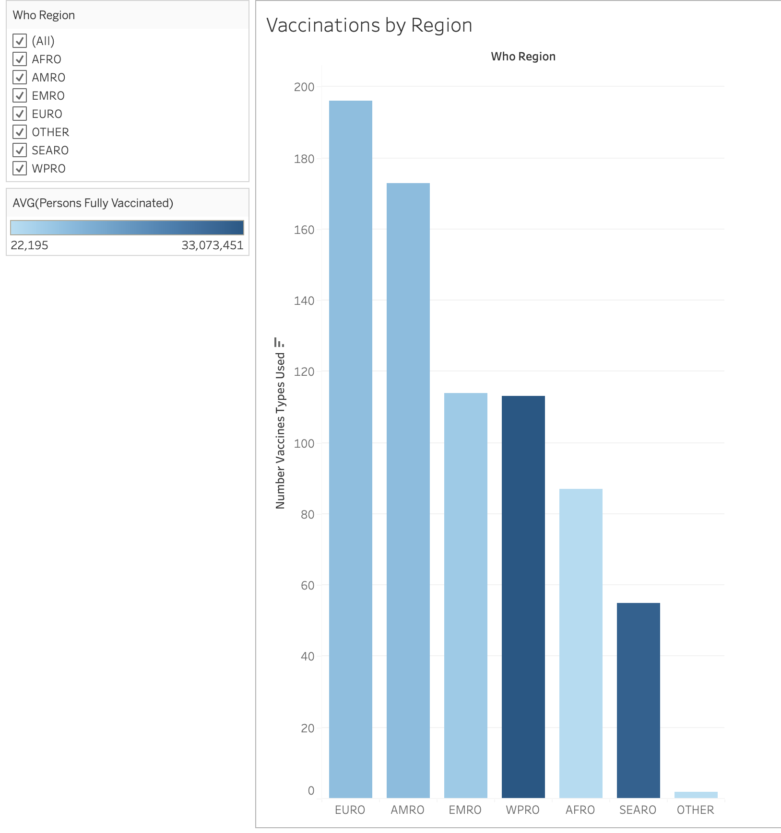

1. **No. of vaccines used by each country**

Philippines used the greatest number of vaccine types (9) followed by Pakistan, Maldives, Bangladesh who had 8 vaccine types. (Sorted in Descending order)

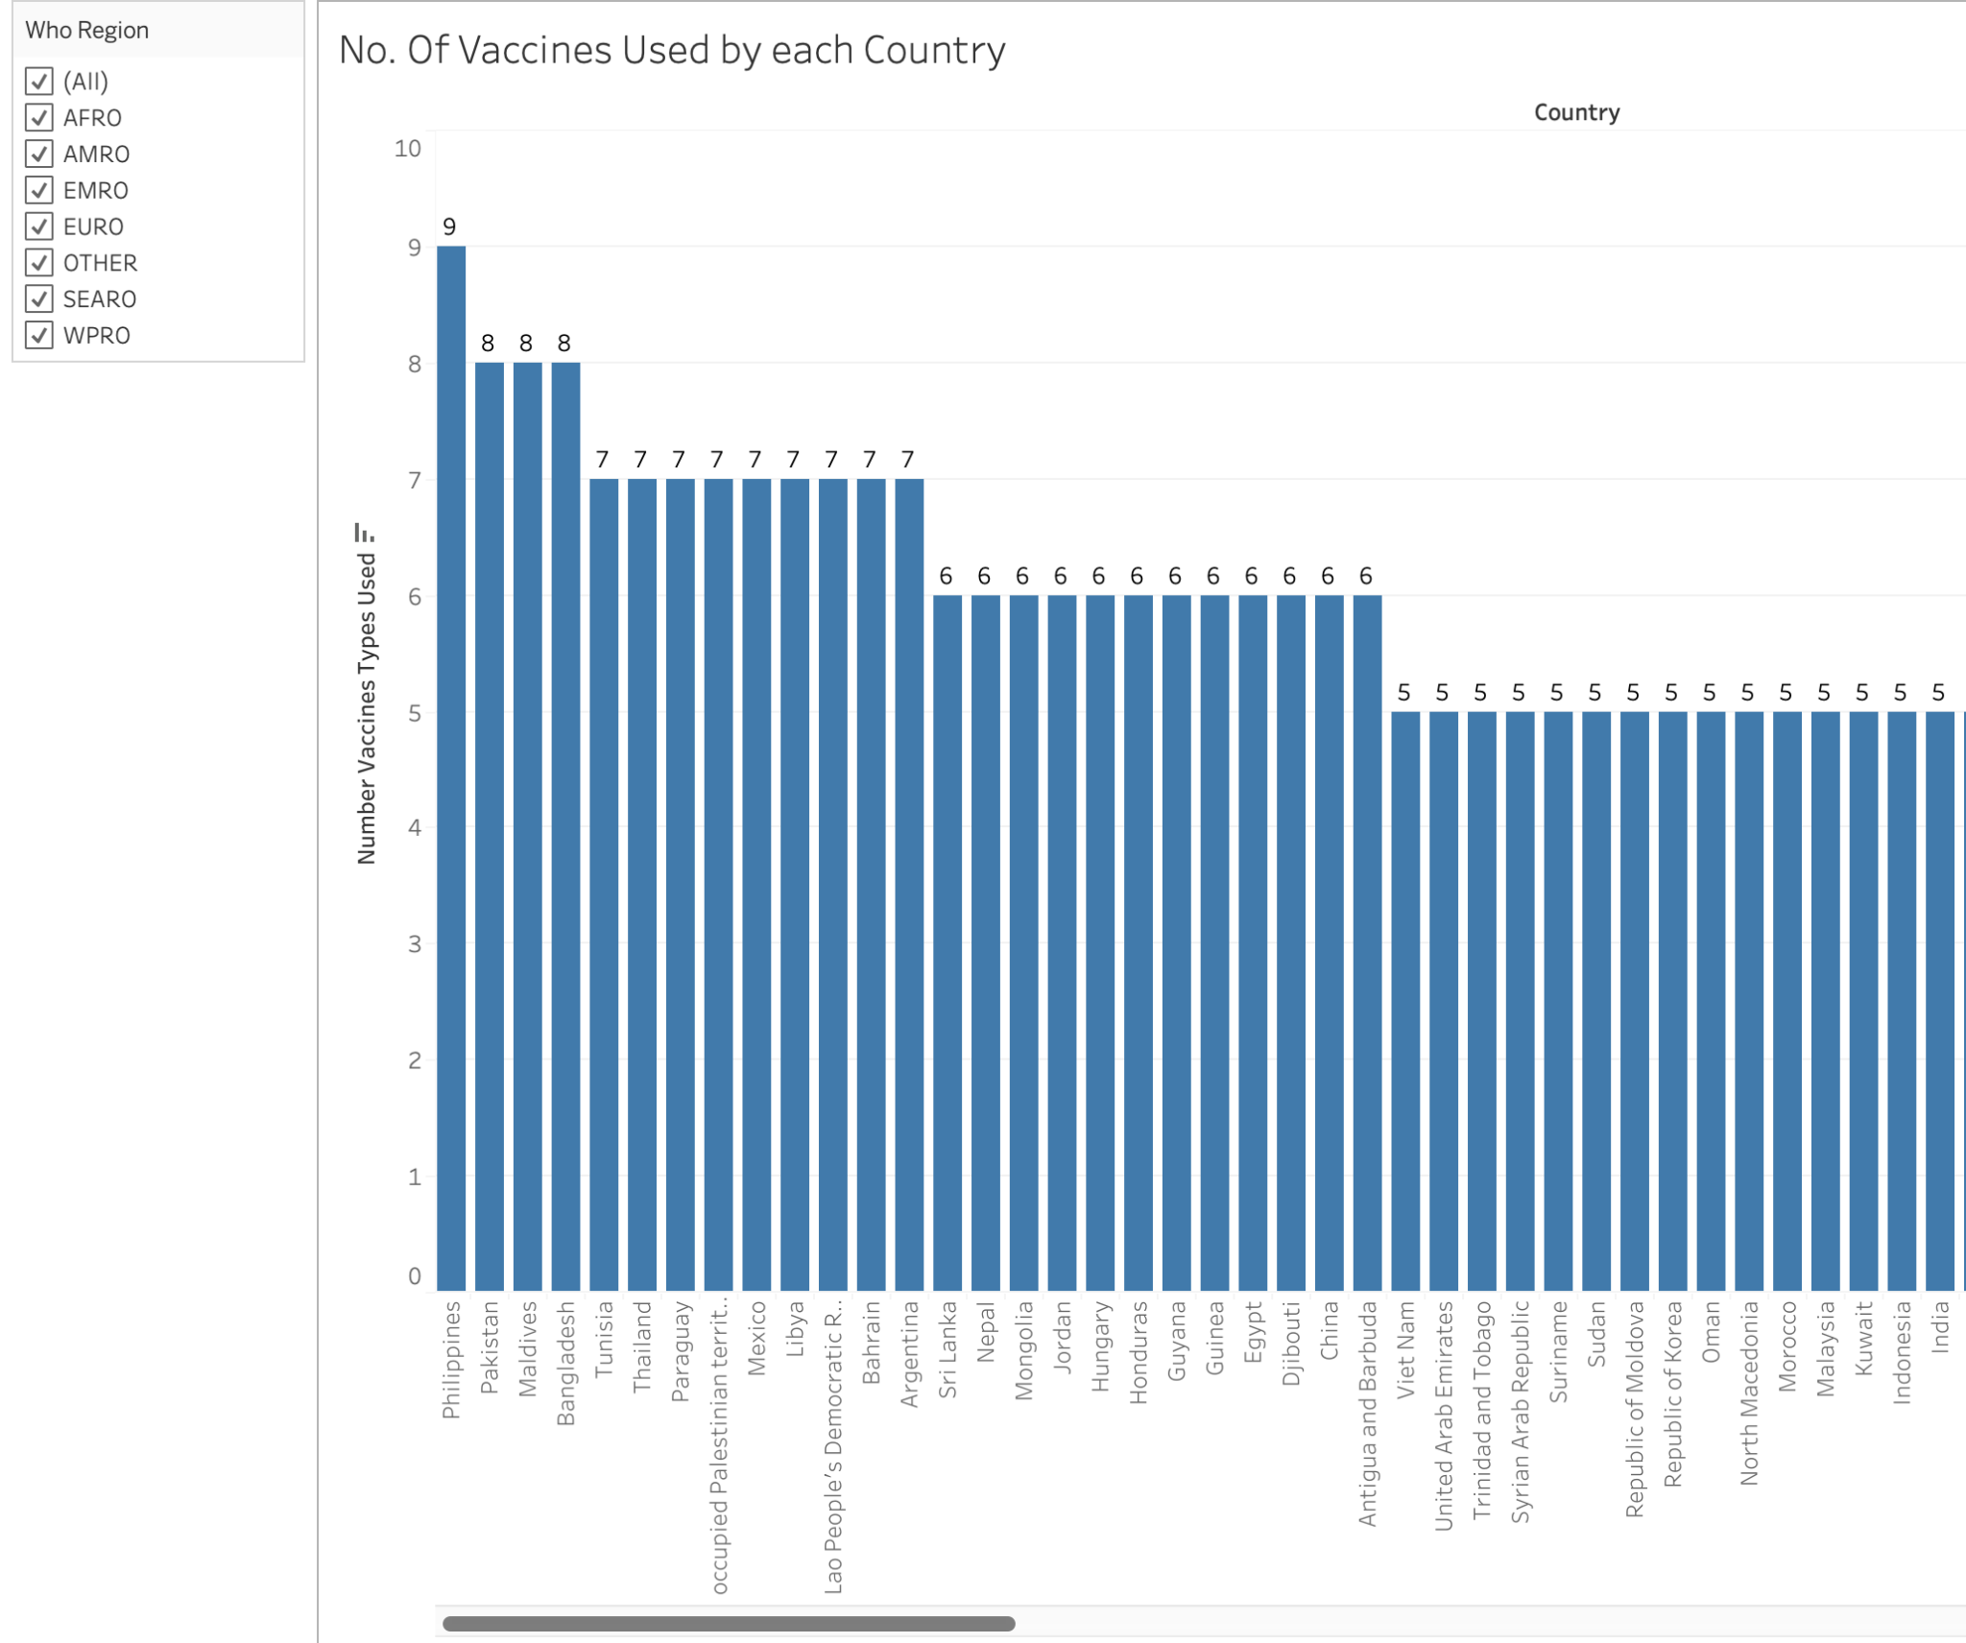

**5. Vaccines popularity** - Pfizer was used by most countries in the world (141), followed by Moderna (89), Covidshield (87).

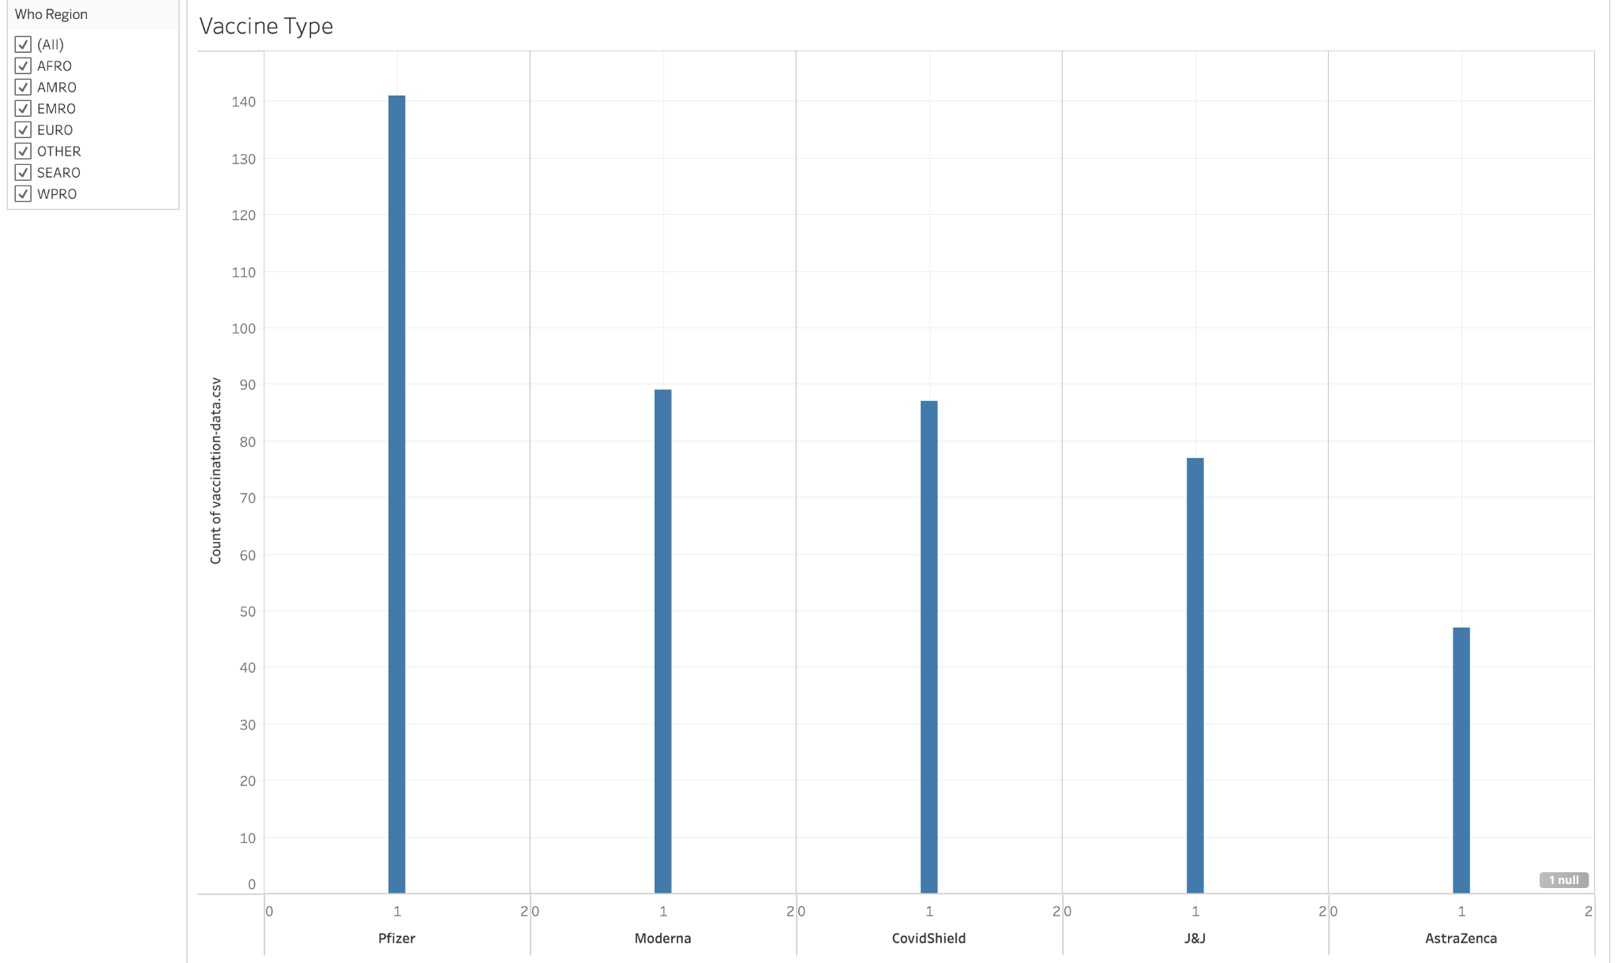

However, in the AFRO Region Covidshield was the most popular vaccine with 39 countries taking this vaccine.

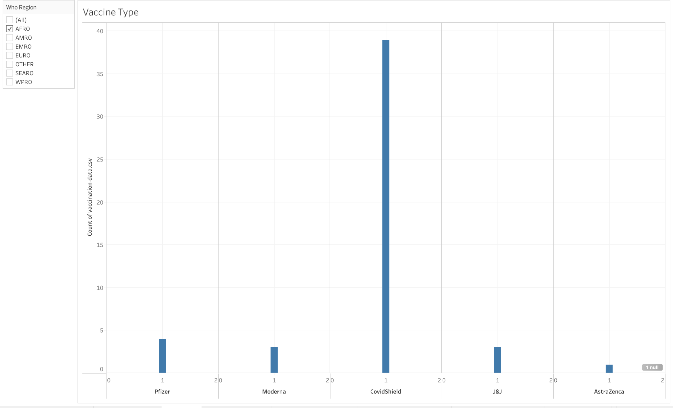

**6. Person fully vaccinated in AFRO Region**

As per experts, it was estimated that 60-70% of the population has to be vaccinated to achieve herd immunity [1]. However, as the dataset provided to us was till September 2021, most countries in the world hadn’t achieved herd immunity against COVID-19. So, we decided to take a hypothetical value, i.e., 50% and considered countries having average people fully vaccinated above this to be successful.

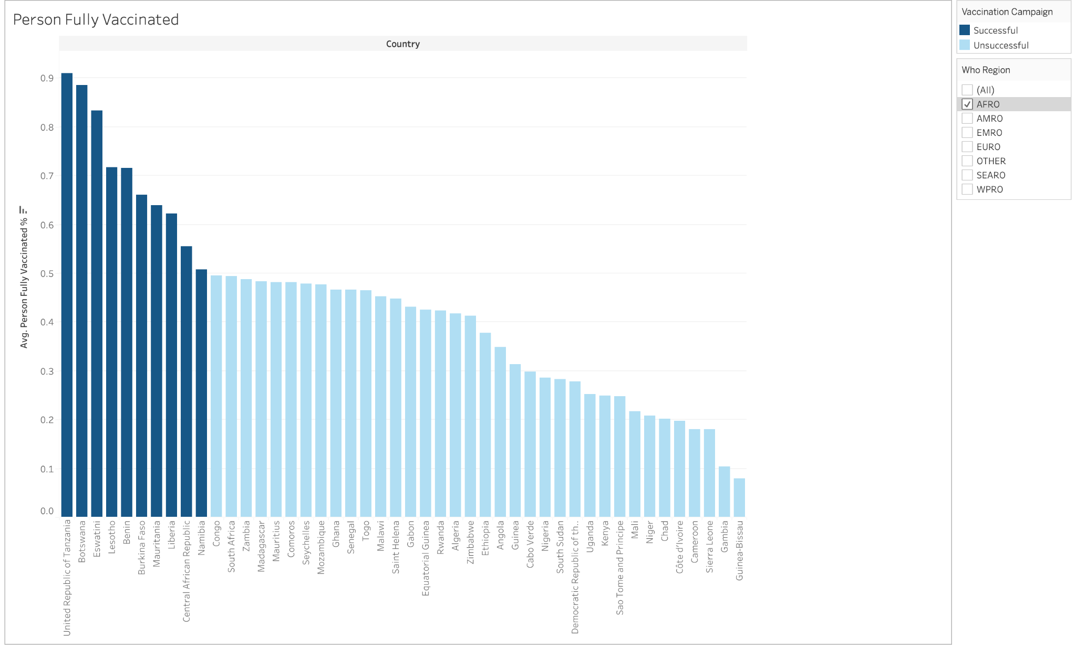

**7. Vaccine Coverage Rate:** This is the proportion of the population that has been fully vaccinated. Its calculated using = Person fully vaccinated / Total population

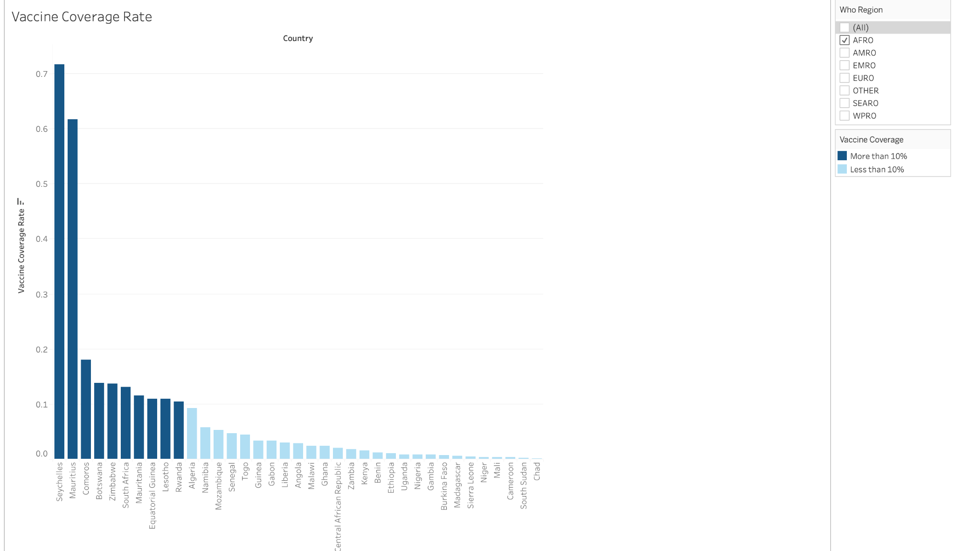

**Outliers: Seychelles, Mauritius**

The reasons why these 2 countries did well during the time of Covid was:

**Geographical isolation:** Both countries are small island nations, which has made it easier to control the movement of people and goods in and out of the country.

**Strong public health infrastructure:** Both countries have well-developed public health infrastructure, including hospitals, clinics, and medical personnel, which has helped to support their pandemic response efforts.

**8. Vaccine Distribution Rate:** This is calculated using - Total vaccinations/ Total population.

A total vaccination/total population value of 1.955 for UAE and 1.666 for Israel indicates that a relatively large proportion of the population in these countries have received at least one dose of a COVID-19 vaccine. Value greater than 1 doesn’t mean that everyone in the country has been vaccinated, as some people may have received more than one dose. Some people may have received 3 doses which includes the booster dose. Rather, it showcases that the total no. of vaccines administered is greater than that total population. These high values indicate that the vaccination campaign in these countries has been successful in reaching a large proportion of the population. [3]

**Why was the UAE so good at vaccine distribution?**

1. **Strong government leadership:** The governments of these countries were proactive in securing vaccine supplies, establishing distribution infrastructure, and communicating effectively with the public about the importance of vaccination.
2. **Efficient vaccine distribution systems:** These countries developed efficient distribution systems that enabled them to administer vaccines quickly and effectively. For example, Israel set up vaccination centers in large stadiums and other public spaces, while the UAE provided mobile vaccination units to reach remote areas.
3. UAE launched COVID-19 vaccine production with China's Sinopharm in joint venture between Sinopharm and Abu Dhabi-based technology company Group 42 (G42). [4]
4. **Easy registration process:** The UAE implemented an easy-to-use online registration process that allowed people to book their vaccination appointments quickly and efficiently.

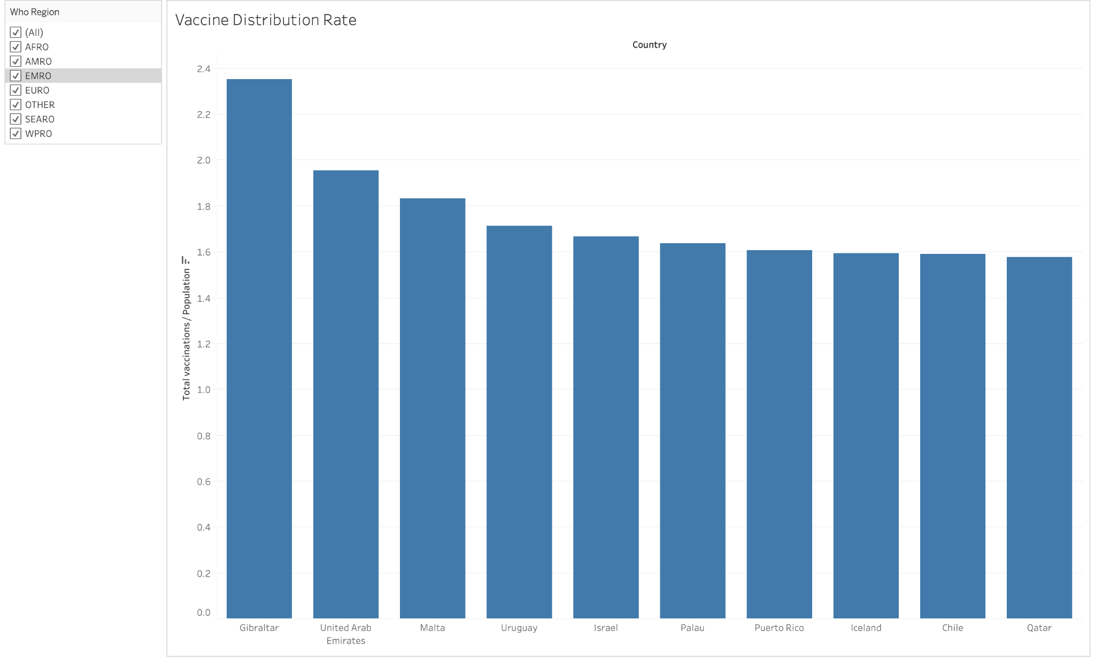

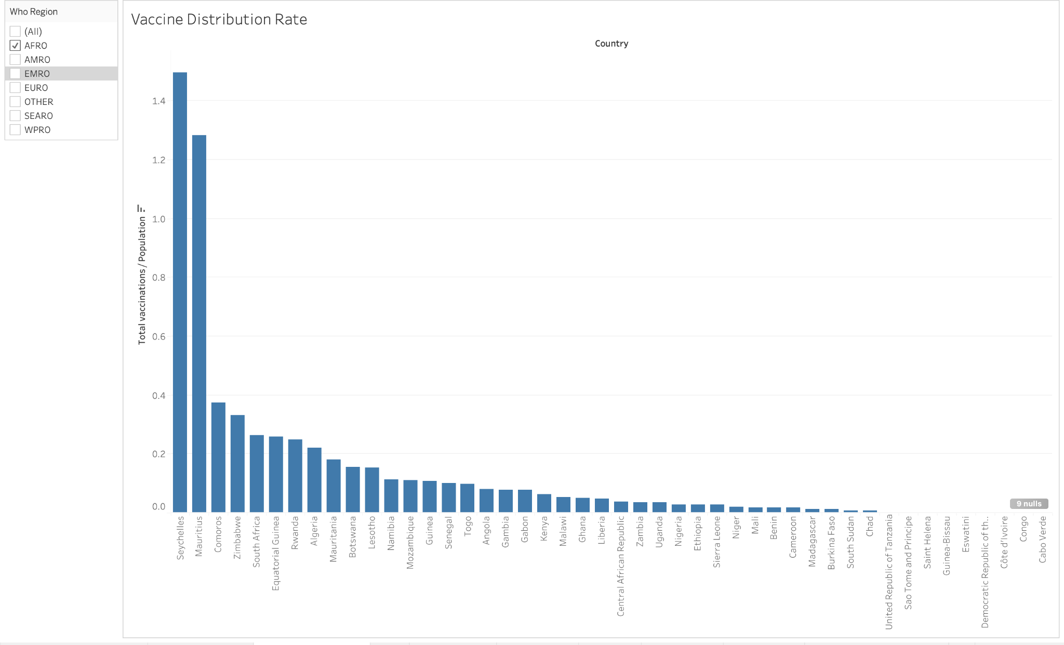

**9. Time Series Analysis (Line Chart) - Deaths**

**No. of deaths filtered by WHO Region**

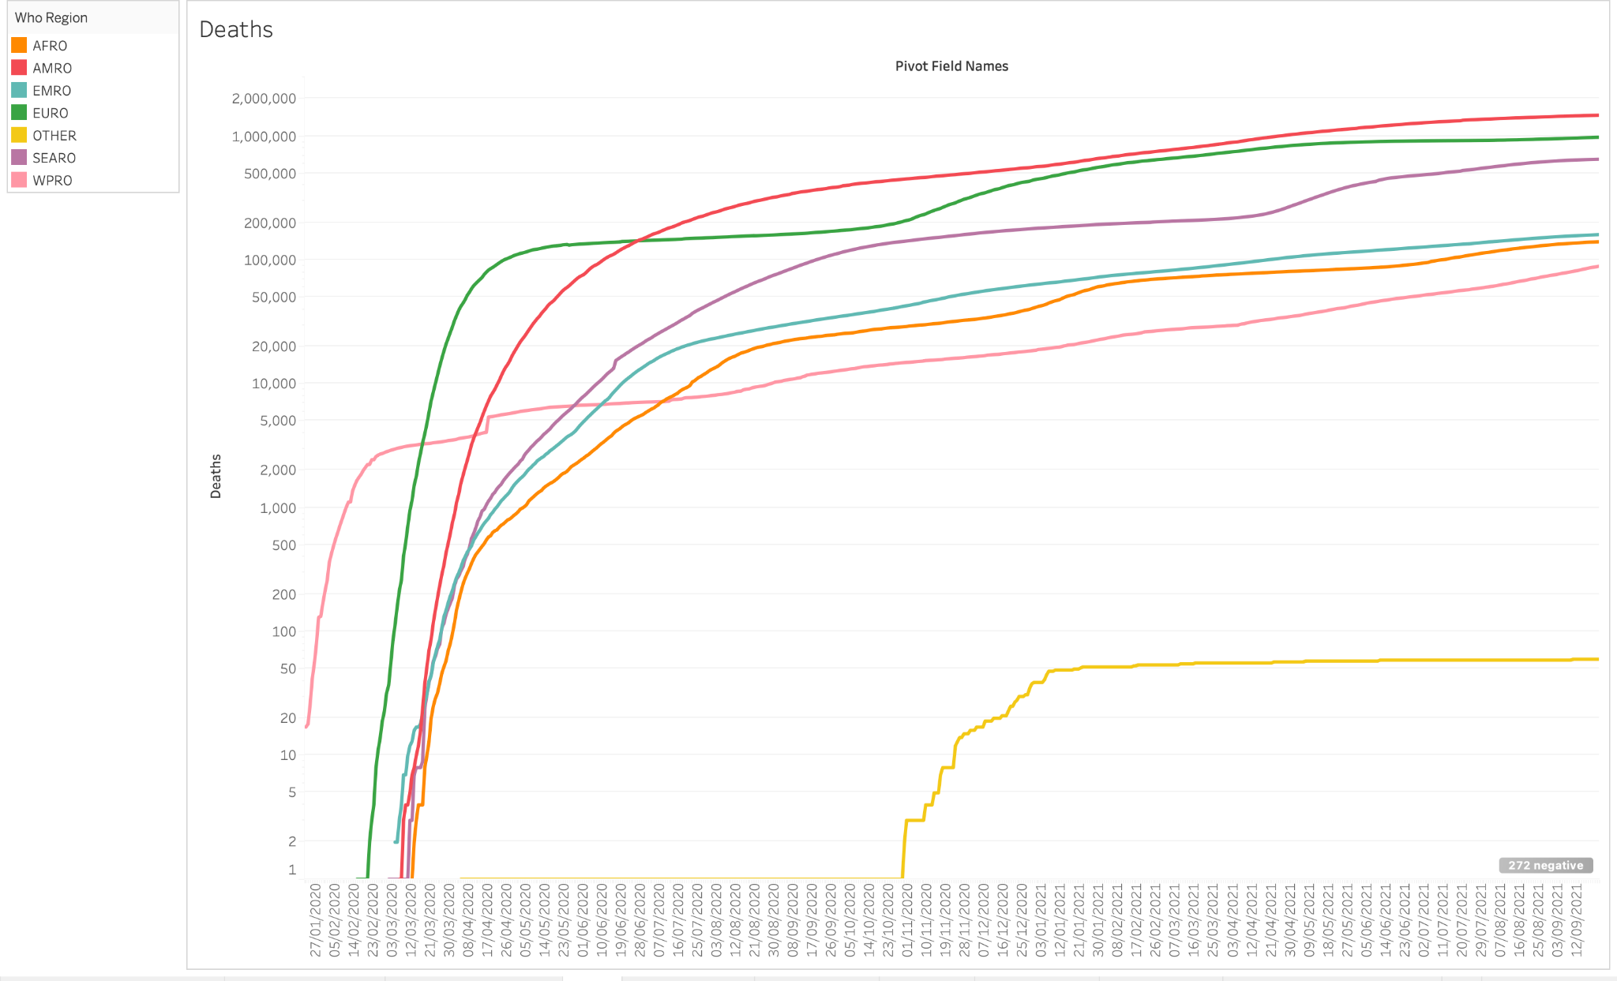

**No. of deaths filtered by WHO Region (Quarterly basis)**

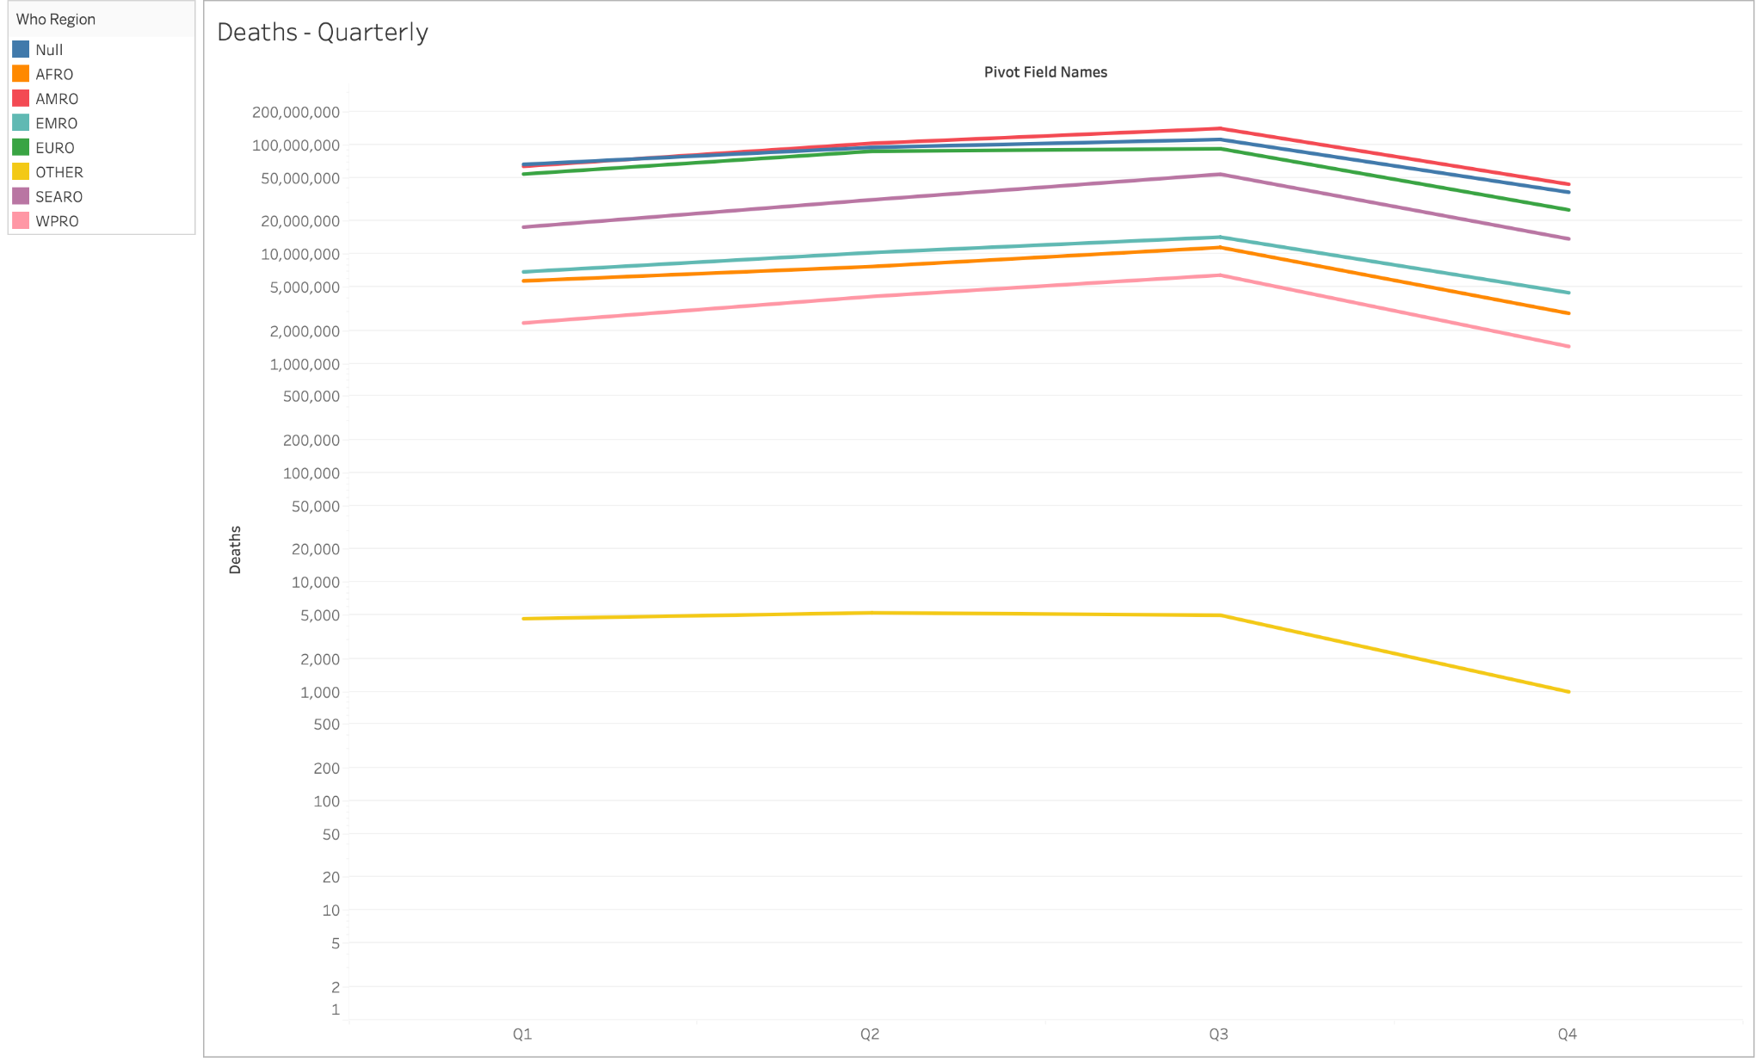

**No. of deaths filtered by WHO Region (Monthly basis)**

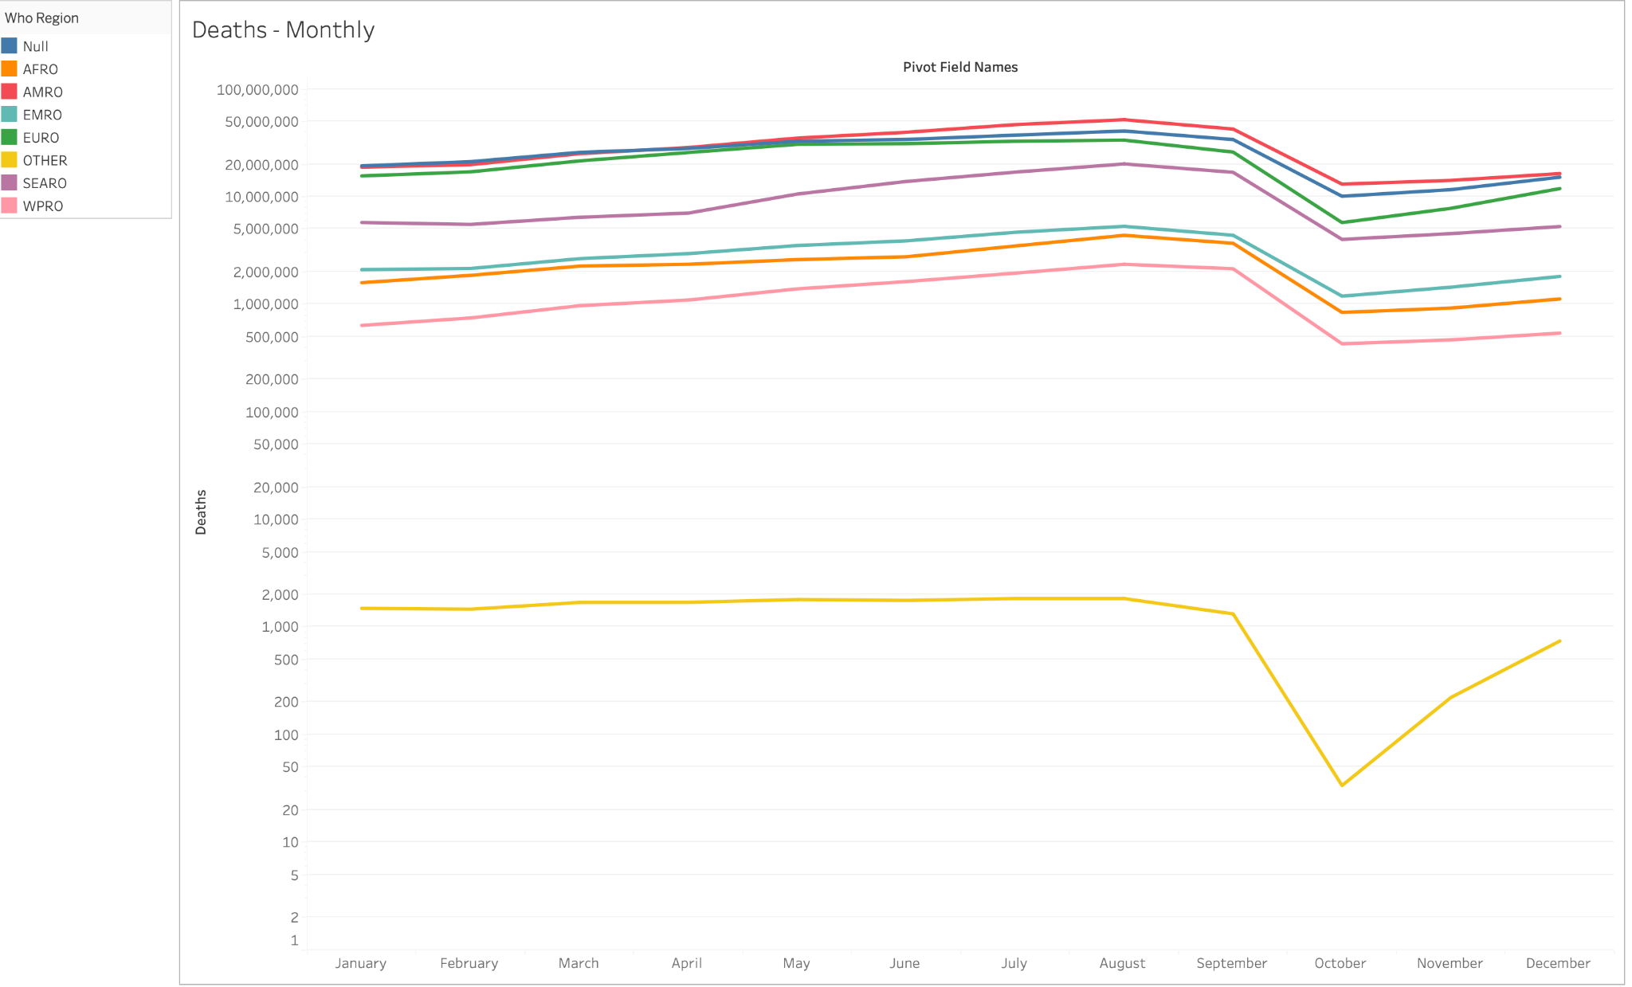

**No. of deaths filtered by WHO Region (Daily basis)**

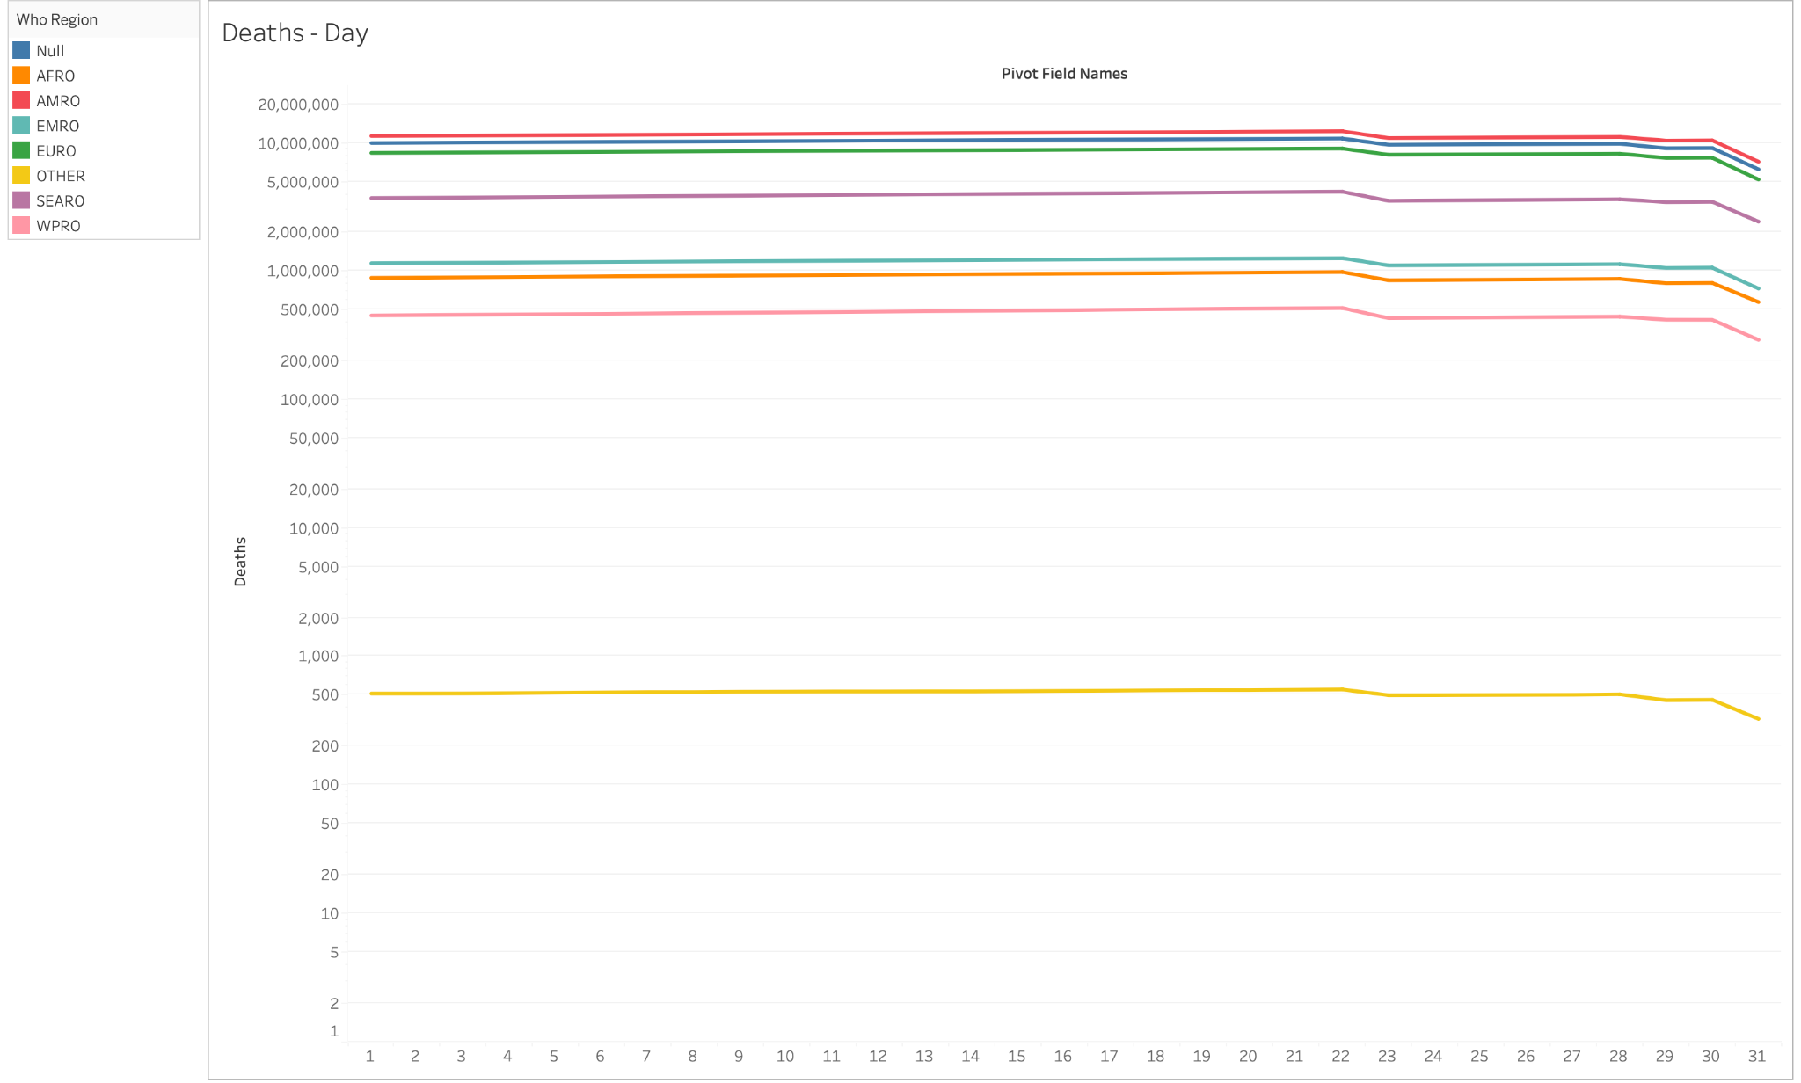

**10. Time Series Analysis - Confirmed cases**

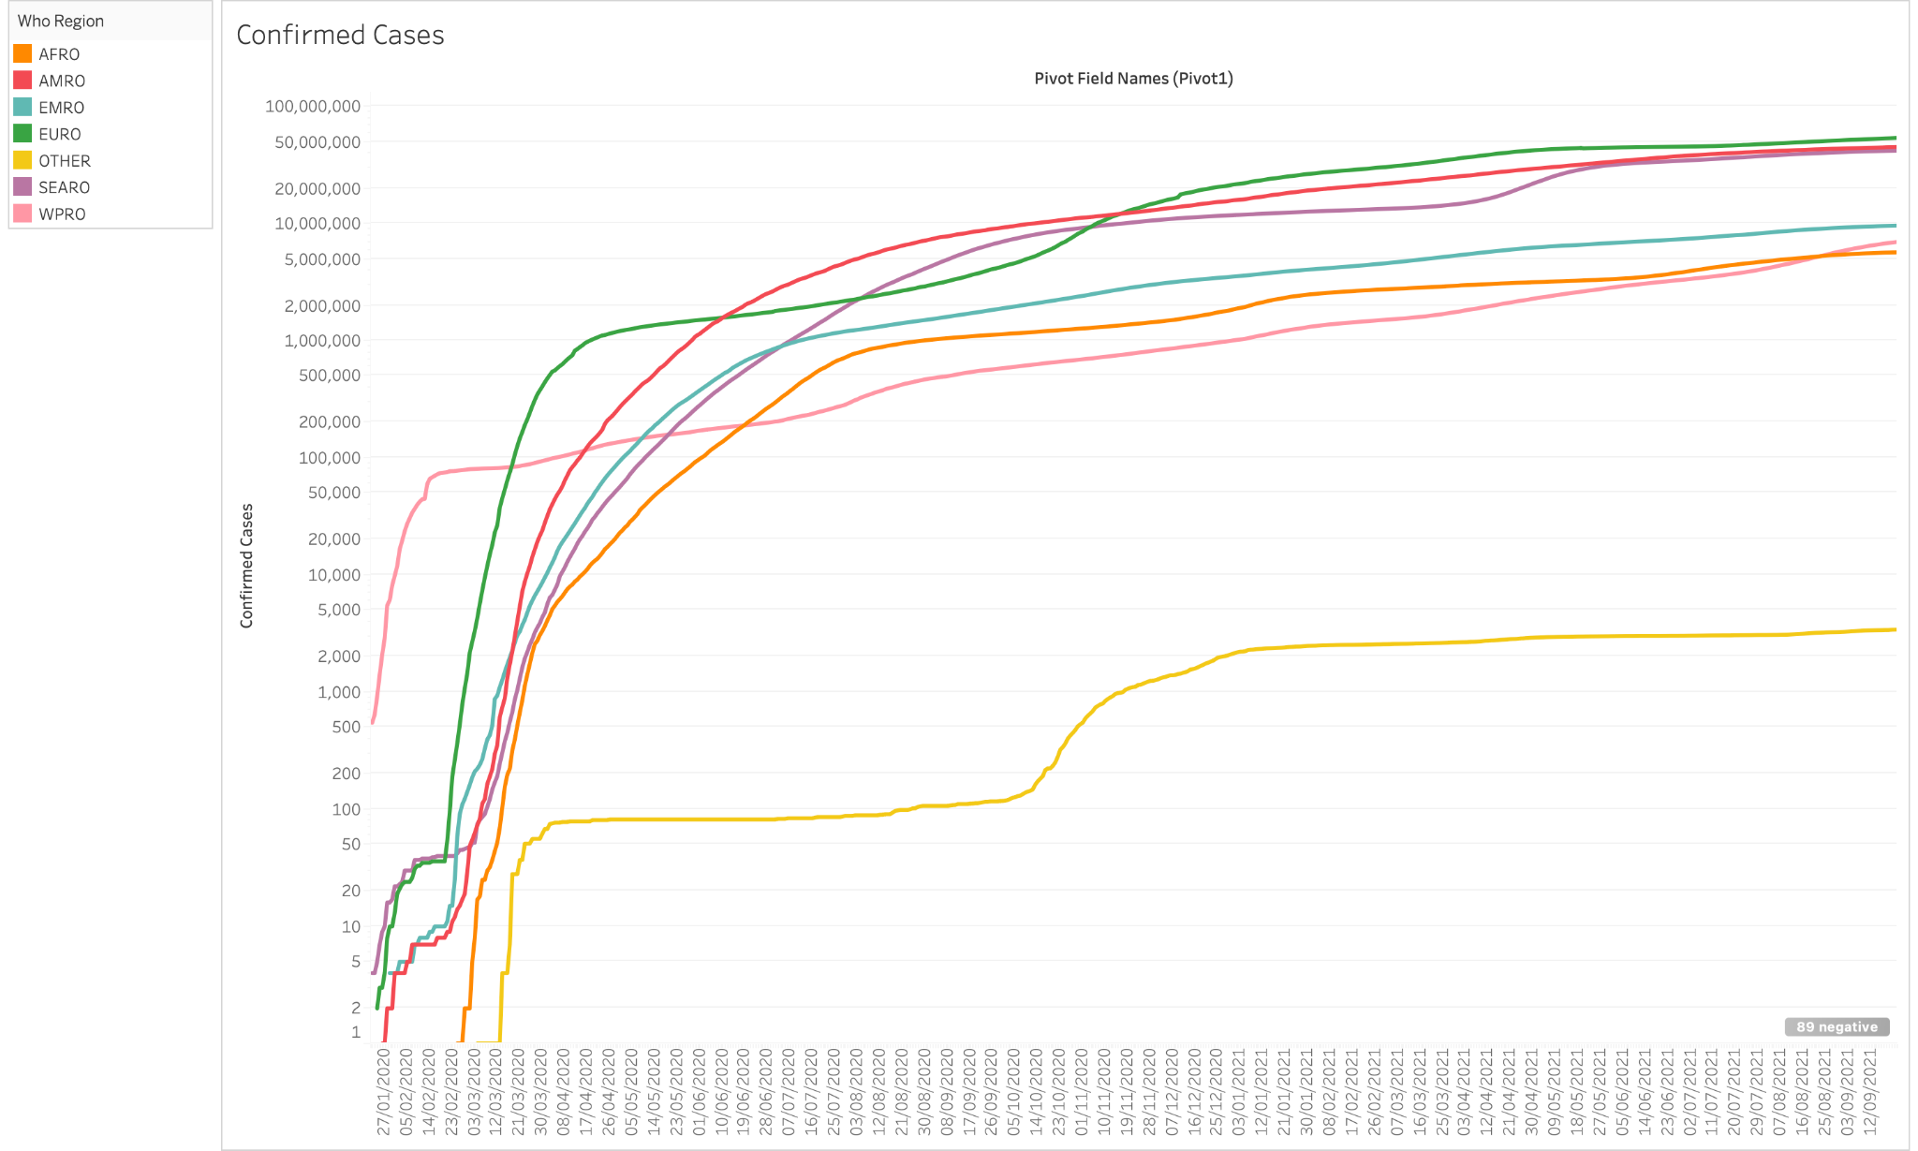

**11. Time Series Analysis - Recovered cases**

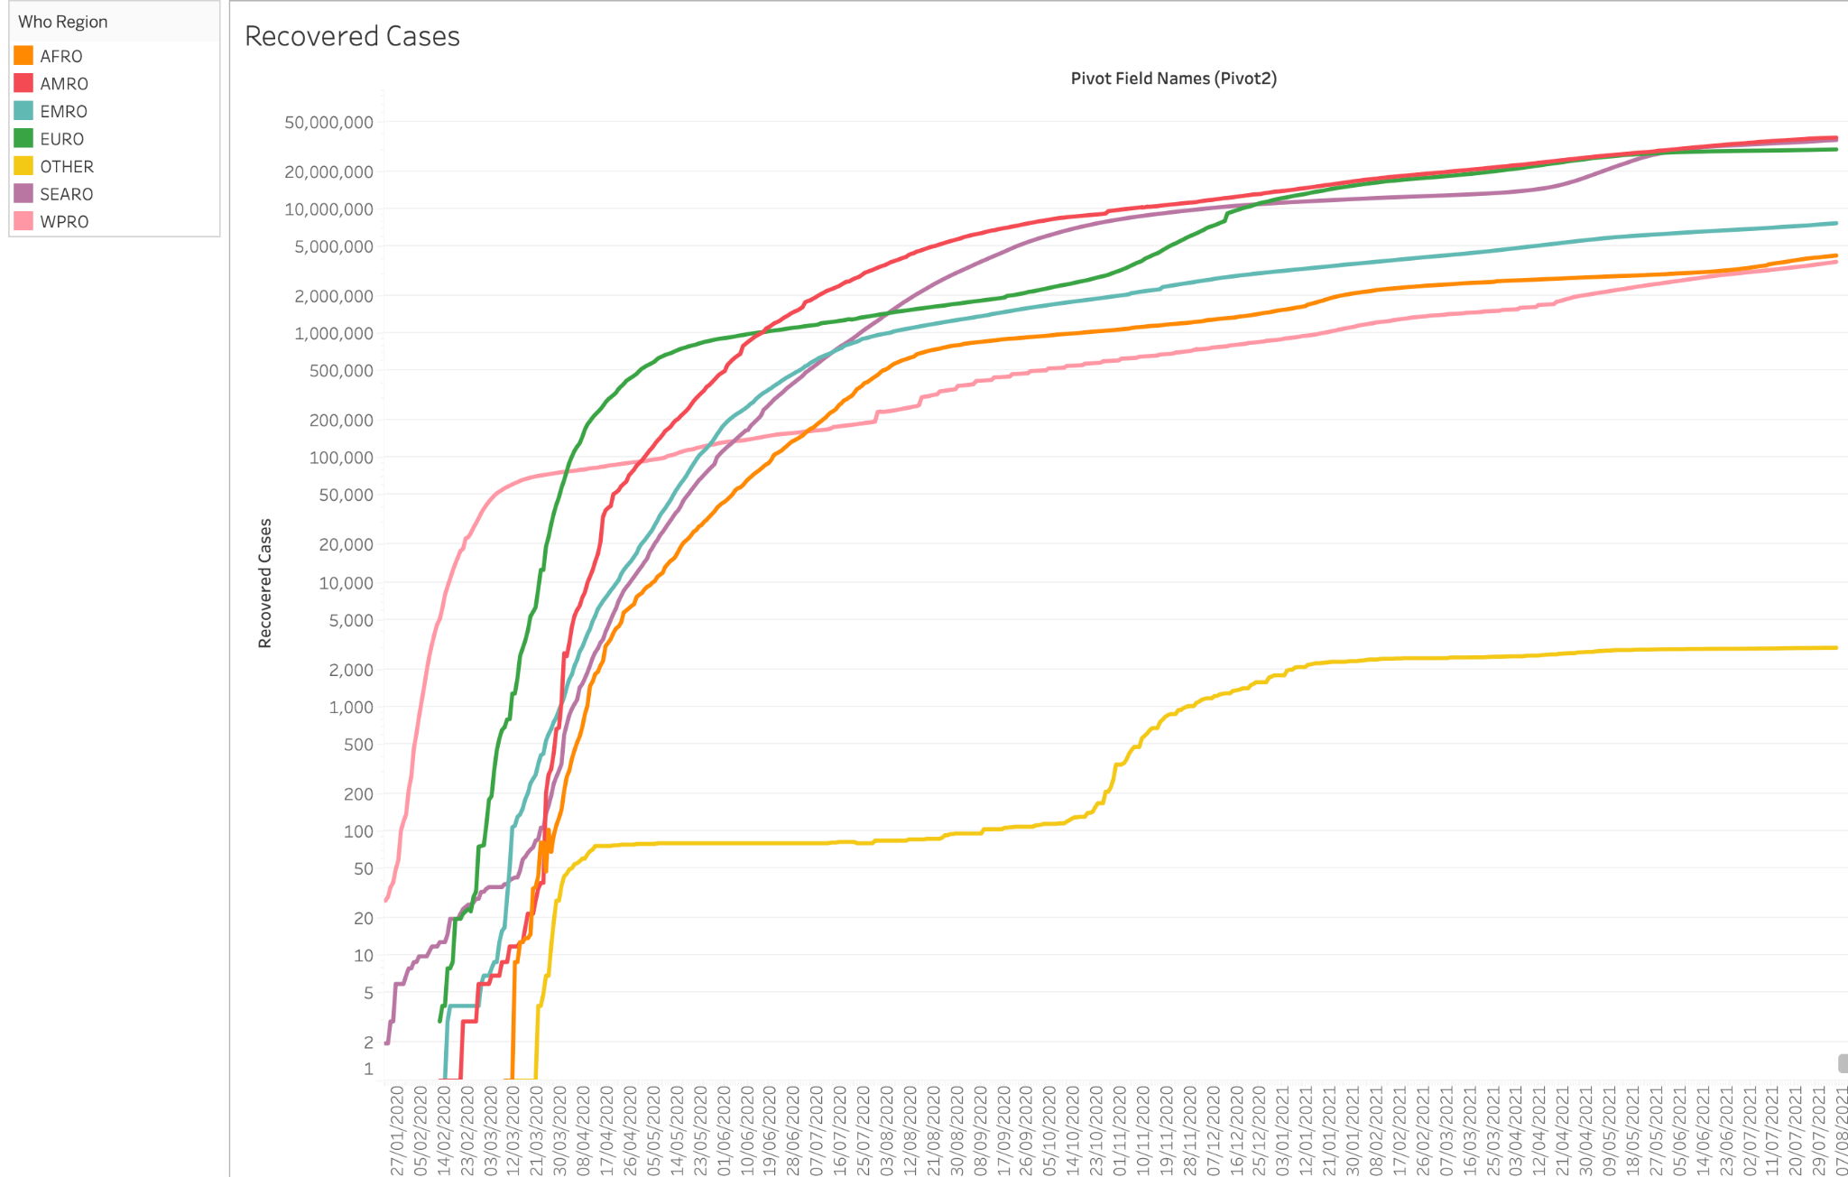

**DASHBOARDS**

1. **Vaccine distribution rate - Deaths - Person vs Total vaccinations per 100**

This has been filtered based on the AFRO Region. All 3 sheets act as filters and are connected with each other.

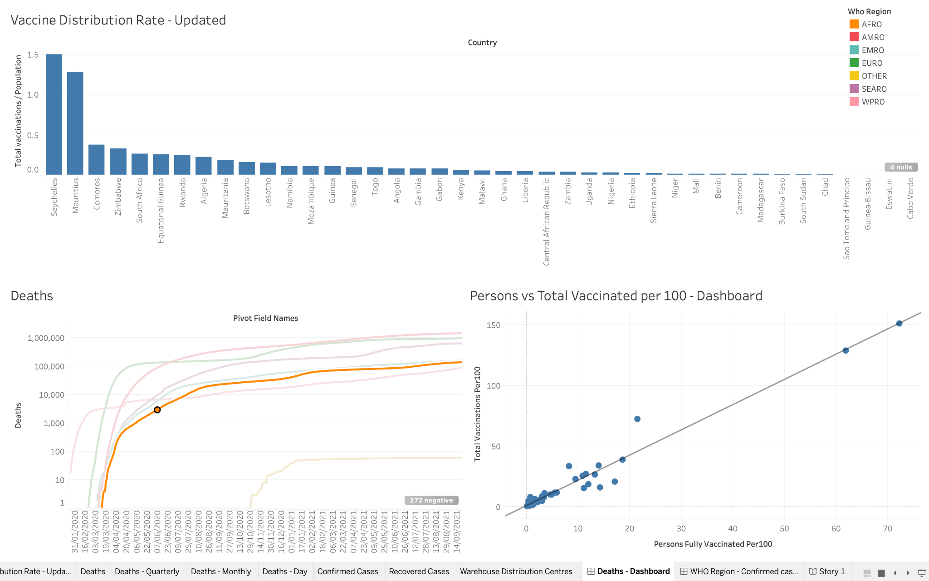

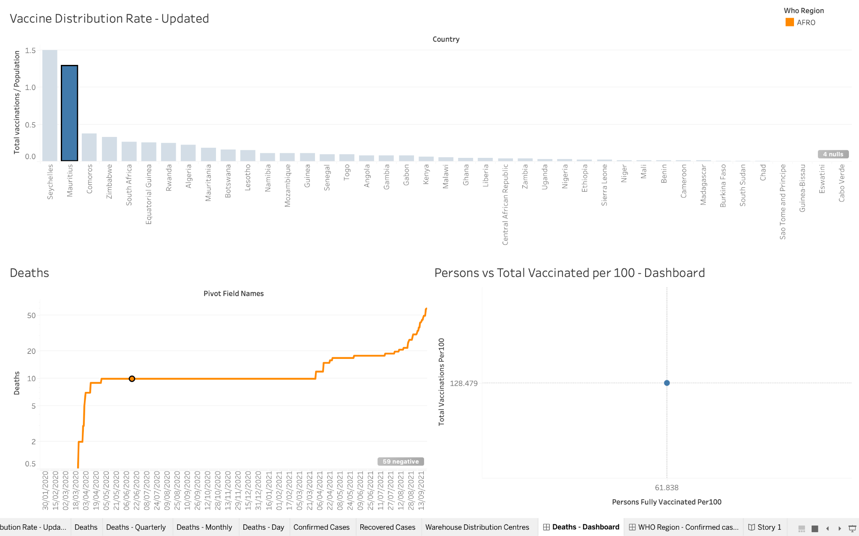

**2. WHO Region - Person fully vaccinated - vaccine type**

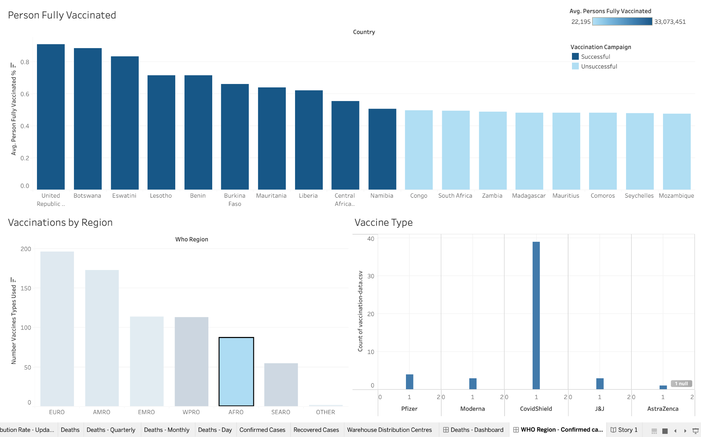

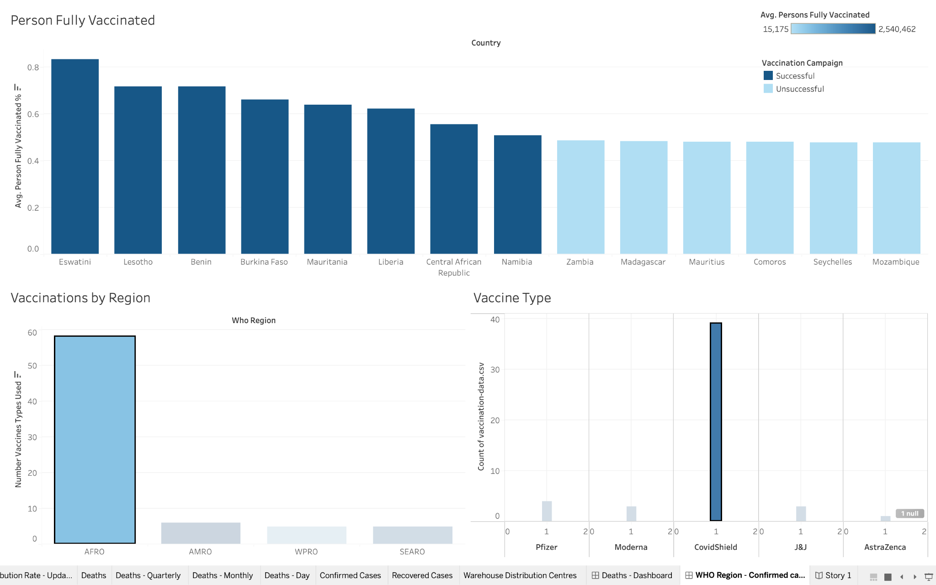

**REFERENCES**

[1] McNeil, D. G., Jr. (2021, September 22). *How Much Herd Immunity Is Enough?* The New York Times. Retrieved February 28, 2023, from https://www.nytimes.com/2020/12/24/health/herd-immunity-covid-coronavirus.html

[2] Meredith, S. (2022, January 13). *Why Cuba’s extraordinary Covid vaccine success could provide the best hope for low-income countries*. CNBC. Retrieved February 26, 2023, from https://www.cnbc.com/2022/01/13/why-cubas-extraordinary-covid-vaccine-success-could-provide-the-best-hope-for-the-global-south.html

[3] Velocity Global. (2021, March 31). *These Five Countries Lead the Worldwide Vaccine Rollout*. Velocityglobal.com. Retrieved February 28, 2023, from https://velocityglobal.com/blog/five-countries-vaccinating-fastest/

[4] Reuters, & Barrington, L. (2021, March 29). *UAE launches COVID-19 vaccine production with China’s Sinopharm*. Reuters. Retrieved February 27, 2023, from https://www.reuters.com/world/middle-east/new-abu-dhabi-plant-manufacture-covid-19-vaccine-chinas-sinopharm-2021-03-29/